**Seeding Possibility-**

**A Review of Riverbank Narrative Cards for Practitioners; Therapists, Teachers, Counsellors**

**created by MariAngels Ferrer-Duch of Riverbank Psychology**

**Reviewed by Dr Joanne Murray & Dr Rhian Hughes**

Clinical Psychologists at Royal Manchester Children’s Hospital

**Our Context**

We are two clinical psychologists working in a paediatric (medical) context. We meet with children, young people, and families who know of the trickiness that living with a health condition can bring. We also meet with staff teams and offer supervision to other clinicians to explore the effects of this work.

We have very recently come to meet ‘Mariangels Ferrer-Duch’s Narrative Cards’ which we fondly call ‘the conversation cards’. We have begun to introduce them to those we work with (individual sessions, family therapy, group work, training, supervision) as well as conversations with each other.

**Our Intentions in this Review**

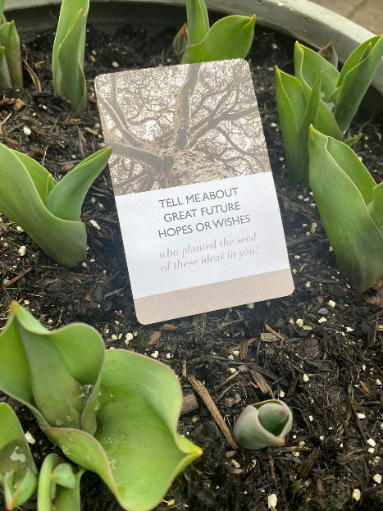Our intention in this ‘review’ is to offer you a glimpse into how these cards have inspired our practice, ‘shouldered us up’ in testing times, and brought playfulness and inspiration to our practice. We grappled with the word ‘review’ – we both agreed that offering a ‘review’ would not quite fit with our narrative intentions. Instead, we offer a ‘witnessing’ – enthusiastically sharing our experience through an outsider witness lens. We invite you to respond and let us know the effects this witnessing has on your own practice (what resonates with your own experience, or where reading our witnessing takes you in your professional journeying). We continue to be inspired and excited about the possible stories that could be unearthed by these wonderful ‘conversation cards’.

**1. What were we drawn to?**

As we reached inside the drawstring bag, the abundant possibilities of the cards scrambled out. We excitedly flicked through the bountiful deck of 48 cards. We were struck both by the simplicity and depth of the questions - so many different directions for exploration!

A card that particularly stood out to us both, and we found ourselves continuing to come back to in sessions and conversations was:

***“What things, activities or ideas make you feel that you are***

***walking toward a special place?”***

We have often considered our role in joining with young people and their families, as though we are joining them on their journeys. Discovering the ‘special place’ card reminded us of the prospect of this ‘special place’ that the conversations we are privileged to take part in are guiding us towards.

**2. What image came to mind?**

The ‘walking towards a special place card’ reminds us of the image of a journey. The journey image has both steep peaks and low pits, with all possible terrains in between, some known, some yet to be discovered. This journey represents the landscape that young people with health conditions can find themselves on. The idea of being on a journey brought to mind the active/evolving process of living with a long-term physical health condition. This landscape also represents our work; the unpredictable, ever-changing and sometimes harsh terrain that can leads us away from our preferred paths and have us feeling a little lost. At the centre of this landscape lies a compass encrusted with precious gems. The reminder of where we are trying to head towards.

The ’conversation cards’ cards, especially the ‘special place’ card, reminds us that there are many gifts we have been given to ‘shoulder us up’, keep us warm, to bring joy and playfulness even to the darkest corners of the journeys that young people can invite us on.

**3. How does this resonate with your own experience?**

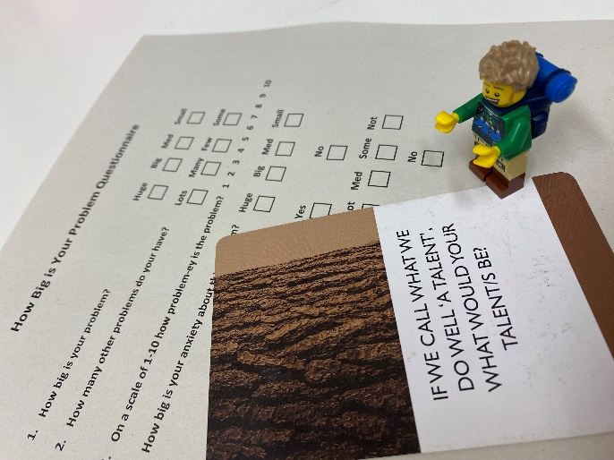As we discuss our attempts to ‘team up with playfulness’, and as we welcome the cards into our ‘bundle of treasures’ that we carry around the hospital, and begin to introduce them to those we work with, we are reminded of the possibilities for anti-seriousness practices made possible by the ‘conversation cards’.

There are many possibilities for us, as psychologists, to fall in the ‘dark hole of business’, to find ourselves in ‘caves of seriousness’, or to venture down paths where we become lost under the weight of the problem. Even our first meeting with young people can be overshadowed by the ‘clinical questionnaires’ we distribute in our waiting room, often fuelling the size of the ‘problem’ and often meaning we meet the problem before the person.

The image of the journey towards a special place reminds us of the many journeys we have been invited on by the young people, families and team members. We remember the subtle and not so subtle responses when we introduce playfulness and narrative-ness into serious or darker terrains of these journeys (e.g., using Lego figures to show how a young person playing with his younger sibling brings calm after the storms of a procedure; a young person holding up a ‘red spikey dragon Lego figure’ to signal that the question we have asked them is leading us down an unhelpful path). In our experiences, the introduction of anti-seriousness (aka playfulness) instigates an explosion of ideas from children whose voices have previously been silenced. Playfulness and alternative practices have shown us possibilities for professionals and teams to be re-invigorated by their ideas, releasing the grip of problems that had intense grip over them. We notice the parallels in how children, young people, parents, clinicians, staff teams, psychologists, us, humans, can all become silenced by seriousness.

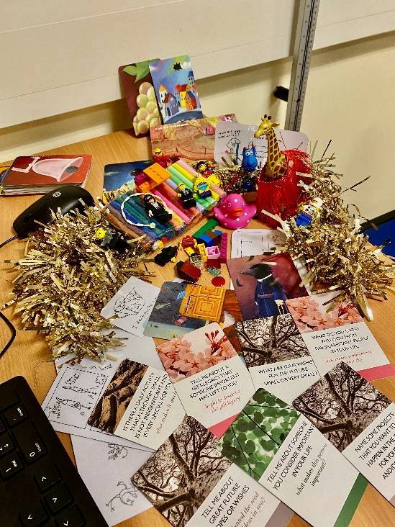**4. Where does this take you?**

The cards, the playfulness, and the ideas we have discussed here, find their place in our ‘bundle of treasures’ which we continue to carry with us. They take us towards the hopefulness of the possibilities for alternative conversations, and they guide us towards opportunities for inspirational or surprising stories from those we come to meet.

As we continue to carry the physical ‘conversation cards’, their physical presence helps cultivate our confidence to bring playfulness and narrative-ness to occasions when we might feel ‘boxed in’ by problem talk or expectations of seriousness.

The simplicity of questions captured within each card reminds us of the value in slowing down and not holding on to narrative maps too tightly. Their simplicity offers a steppingstone into a narrative wonderland, upfolding into possibilities that are shaped by those at the centre of the conversation (rather than the therapist!).

Finally, the presence of Mariangels’ ‘conversation cards’ in our bundle reminds us of the power in joining together and ‘teaming up’ and ‘shouldering up’ that is required to keep these ideas in circulation. We look forward to the many possibilities that are not yet tried out as we take steps towards professional ‘teaming up’ adventures, and invite new teams, services, young people and others into alternative and preferred narratives.

Riverbank Cards are available directly from MariAngels Ferrer-Duch who can be contacted on <https://riverbankpsychology.co.uk./shop/>

and at [mariangelsferrer@riverbankpsychology.co.uk](mailto:mariangelsferrer@riverbankpsychology.co.uk)

Please note that the cards will also be available at Conference and workshop events hosted by INT.